11 PSYCHOLOGY 2015

TEST TWO

Name: ____________________ Teacher: ___________________ Mark: /50

Percentage: %

Section One: Research methods (15 marks)

Question 1

State two disadvantages of collecting population data. (2 marks)

_____________________________________________________________________________________

_____________________________________________________________________________________

Question 2

Provide a psychological definition of ‘validity’. (2 marks)

_____________________________________________________________________________________

_____________________________________________________________________________________

_____________________________________________________________________________________

Question 3

Calculate the mode, mean, median and range for the following set of data. (4 marks)
(You do not need to show working out).

10, 13, 27, 17, 16, 15, 27, 27, 28, 24, 27, 15

a) Mode:

b) Mean:

c) Median:

d) Range:

Question 4

State the measure of central tendency that is most affected by extreme scores. (1 mark)
_____________________________________________________________________________________

Question 5

The table below shows the number of mobile phones owned by people in a population.
Ages | Mobile phones owned
10-14 | 3
15-19 | 2
20-24 | 6
25-29 | 7
30-34 | 5
35-39 | 2
40-44 | 5

State the type of graph you would draw to represent this information and explain the reason for your choice of graph. (2 marks)

_____________________________________________________________________________________

_____________________________________________________________________________________

_____________________________________________________________________________________

Question 6
For the following scenarios, identify the operationalised independent variable and operationalised dependent variable.

a) Dr Woodford, a psychologist, was concerned about the levels of stress in local council employees. He wanted to investigate whether he could lower their stress levels, as measured by a self-report inventory, by medicating them daily with Clarinodroxyl. A control group completed the same inventory but did not take any of the medication. (2 marks)

Operationalised independent variable: _____________________________________________________

_____________________________________________________________________________________

Operationalised dependent variable: _______________________________________________________

_____________________________________________________________________________________

b) For his PhD, a university student investigates the effects of sleep deprivation on adults solving simple mathematical problems. He keeps Group 1 awake for 12 hours, Group 2 awake for 24 hours, Group 3 awake for 36 hours and Group 4 awake for 48 hours. He then gives all participants a series of basic arithmetic problems to solve. (2 marks)

Operationalised independent variable: _____________________________________________________

_____________________________________________________________________________________

Operationalised dependent variable: _______________________________________________________

_____________________________________________________________________________________

Section Two: Short answer (22 marks)

Question 7

Describe the location of the corpus callosum and state what its function is. (2 marks)

_____________________________________________________________________________________

_____________________________________________________________________________________

_____________________________________________________________________________________

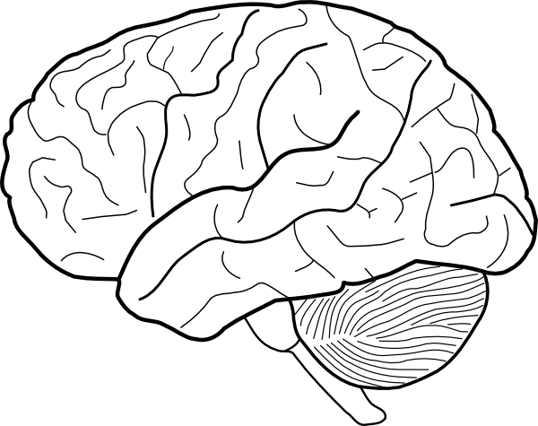
Question 8 (3 marks)

Look at the hemisphere shown in the diagram above. List three functions of this hemisphere.

_____________________________________________________________________________________

_____________________________________________________________________________________

Question 9

Contrast still pictures and dynamic pictures. (2 marks)

_____________________________________________________________________________________

_____________________________________________________________________________________

_____________________________________________________________________________________

_____________________________________________________________________________________

Question 10

There are four lobes in each hemisphere of the brain. State the name of each lobe and state what it is mainly responsible for. (8 marks)

____________________________________________________________________________________

_____________________________________________________________________________________

____________________________________________________________________________________

_____________________________________________________________________________________

____________________________________________________________________________________

_____________________________________________________________________________________

____________________________________________________________________________________

_____________________________________________________________________________________

Question 11 (3 marks)

State what EEG (electroencephalograph) is used to measure and describe what it is used to find.

_____________________________________________________________________________________

_____________________________________________________________________________________

_____________________________________________________________________________________

_____________________________________________________________________________________

Question 12

a) Label the diagram below. (3 marks)
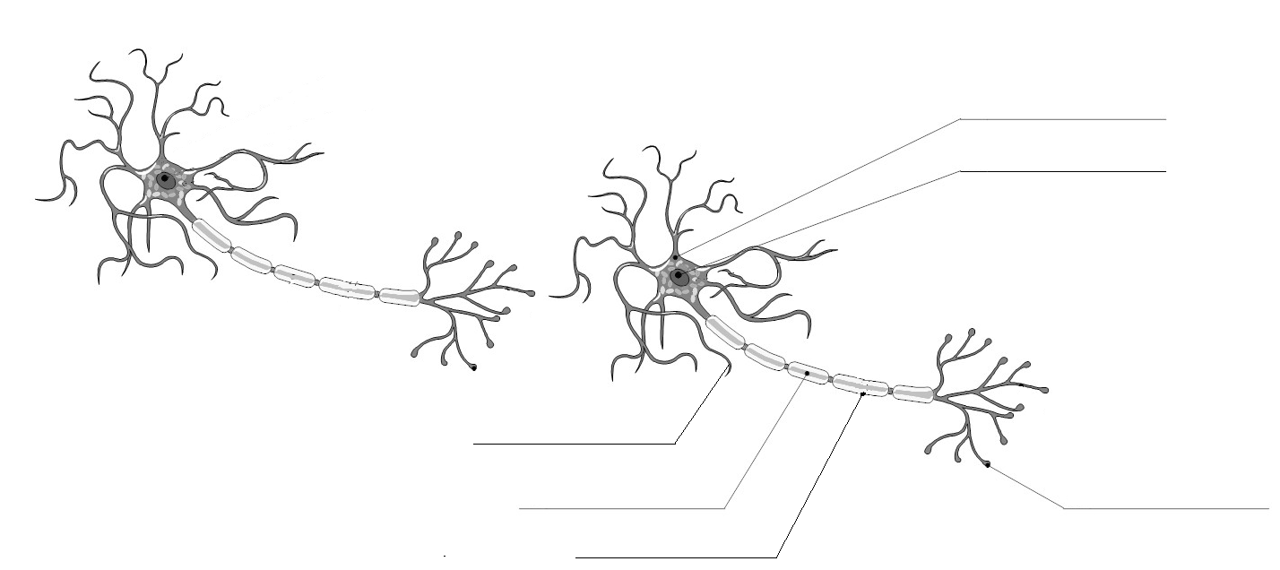
b) Draw arrows showing the path of a nerve impulse along/between the two neurons. (1 mark)
Section three: Extended answer (13 marks)

This section contains one (1) question that you must answer.

Pages are included at the end of the question for planning and writing your answer.
⬧ Planning: If you use a page for planning, indicate this clearly at the top of the page.
⬧ Answering the question: In the pages provided indicate clearly the section of the question you are
answering.

Suggested working time: 20 minutes.
_____________________________________________________________________________________

Question 13

In the past two decades, emerging neuroimaging techniques have allowed psychologists to peer deep into the healthy, living brain. These techniques include CAT scans, MRI, fMRI and PET scans.

For each of the above-mentioned techniques, include the following information in your answer:

⬧ Whether the technique takes still or dynamic pictures.
⬧ Whether a tracer can be used in the technique.
⬧ A description of what the technique is used for (in relation to the brain).

_____________________________________________________________________________________

_____________________________________________________________________________________

_____________________________________________________________________________________

_____________________________________________________________________________________

_____________________________________________________________________________________

_____________________________________________________________________________________

_____________________________________________________________________________________

_____________________________________________________________________________________

_____________________________________________________________________________________

_____________________________________________________________________________________

_____________________________________________________________________________________

_____________________________________________________________________________________

_____________________________________________________________________________________

_____________________________________________________________________________________

_____________________________________________________________________________________
_____________________________________________________________________________________

_____________________________________________________________________________________

_____________________________________________________________________________________

_____________________________________________________________________________________

_____________________________________________________________________________________

_____________________________________________________________________________________

_____________________________________________________________________________________

_____________________________________________________________________________________

_____________________________________________________________________________________

_____________________________________________________________________________________

_____________________________________________________________________________________

_____________________________________________________________________________________

_____________________________________________________________________________________

_____________________________________________________________________________________

_____________________________________________________________________________________

_____________________________________________________________________________________

_____________________________________________________________________________________

_____________________________________________________________________________________

_____________________________________________________________________________________

_____________________________________________________________________________________

_____________________________________________________________________________________

_____________________________________________________________________________________

_____________________________________________________________________________________

_____________________________________________________________________________________

_____________________________________________________________________________________

_____________________________________________________________________________________

_____________________________________________________________________________________
_____________________________________________________________________________________

_____________________________________________________________________________________

_____________________________________________________________________________________

_____________________________________________________________________________________

_____________________________________________________________________________________

_____________________________________________________________________________________

_____________________________________________________________________________________

_____________________________________________________________________________________

_____________________________________________________________________________________

_____________________________________________________________________________________

_____________________________________________________________________________________

_____________________________________________________________________________________

_____________________________________________________________________________________

_____________________________________________________________________________________

_____________________________________________________________________________________

_____________________________________________________________________________________

_____________________________________________________________________________________

_____________________________________________________________________________________

_____________________________________________________________________________________

_____________________________________________________________________________________

_____________________________________________________________________________________

_____________________________________________________________________________________

_____________________________________________________________________________________

_____________________________________________________________________________________

_____________________________________________________________________________________

_____________________________________________________________________________________

_____________________________________________________________________________________

